Assignment 6 – Report and Reflection

1. **The chosen teaching method**

My chosen teaching method was interactive lessons with different types of activating forms. The activating forms include questions-answers at the beginning of the lesson, peer-instruction/presentation, and discussions with peers. I did this in the course “environmental dynamic modeling”, a training on how to build dynamic models related to environmental problems using a software called Powersim. I also included some feedback sessions and exercises with increasing difficulty (stagged or stepped exercises) technique on this lesson when we were building the model.

I started the lesson with activating the students by asking them questions about last week’s material, instead of explaining myself what they should have learned last week. Afterwards, I also let some students do peer-instruction by explaining their model from last week/previous lesson. The students could also give comments and feedback on their peers’ model, as everyone could build various models with similarity (as long as the model actually worked).

When building the model, I did not explain everything and let them build the final model all at once, but I explained in parts and built up the difficulty. Lecture was given in several parts. Part 1 was about building the basic of the model, part 2 was about improving the model, and part 3 was finalising the model. I will also explain the relevance of this training in broader aspect of environmental science.

1. **The specific characteristics**

As I applied different types of teaching styles in this lesson, I will not elaborate on all teaching styles that I used. In this section, I want to elaborate more about the **interactive lesson with activating forms** and the **importance of giving feedback**. As for **peer instruction**, it will be discussed further in Assignment 10.

Interactive lesson with activating form is basically a form of teaching that promotes the interaction between student and teacher. It aims to turn monologue teaching style where students just passively listen to the teacher into more active style, in which the students act as an active learner. Including questions-answers session and small exercises as activating forms in the lecture will make learning become more substantial and create engagement of students with the discussed topics (Vilonen et al., 2008). There are multiple advantages and disadvantages of using activating forms, as given in Table 1.

*Table 1. Advantages and disadvantages of using activating form*

|  |  |
| --- | --- |
| **Advantages** | **Disadvantages** |
| Develop students’ communication and presentation skills (Tureková et al., 2020). | Activating forms and student-centered learning can have negative impact on students’ knowledge (Fischer & Hänze, 2019). |
| Increase students’ awareness about the problems (Hrmo et al., 2015). | Students can be very negative about it or do not like this teaching style (Fischer & Hänze, 2019). |
| Enhance students’ critical thinking (Tureková et al., 2020). |  |

Because of the advantages and disadvantages, I formulated some do’s and don’t’s for this teaching style, as shown in Table 2.

*Table 2. Do’s and don’t’s in applying activating forms in your lesson*

|  |  |
| --- | --- |
| **Do’s** | **Don’t’s** |
| Use it to recap the learning materials, it is very useful for opening and closing your lesson. In opening, it is used to clarify the lesson objectives from the previous week, and as closing it is useful to emphasise again on the lesson objectives of that specific lesson. | Do not use it too much. We can challenge the students, but do not challenge them to the point where they can break down. |
| Try to include everybody, including shy or introverted students. | Do not always ask the same vocal or extroverted students to participate. |
| Keep track of the time and the structure of your lesson. | Do not get carried away with all responses from the students. Know when and where to stop. |

I also applied peer feedback in this lesson, in which some students presented their models and then other students give feedback, comments, remarks about their models. Peer feedback is mainly used to comprehend the current step of learning, so students can continue to the next step of learning and fix some errors in their reasoning (Molin et al., 2021). There are some advantages and disadvantages in the application of peer feedback, as shown in Table 3.

*Table 3. Advantages and disadvantages of using peer feedback*

|  |  |
| --- | --- |
| **Advantages** | **Disadvantages** |
| Promote the behavioural, affective, and cognitive engagement of the students (Zhang & Hyland, 2022). | Not everybody is willing to spend time to react and reflect to feedback given by their peers (Zhang & Hyland, 2022). |
| Provide emotional support and promote  collaborative learning (Zhang & Hyland, 2022). | Mixed feelings about peer feedback (Zhang & Hyland, 2022). |
| Result in greater learning gains if it is followed by  teacher feedback (Molin et al., 2021). | Does not automatically result in positive effects on student performance (Molin et al., 2021). |
| Support the retaining of information or knowledge in long-term if combined with teacher feedback (Molin et al., 2021). |  |

Some do’s and don’t’s in applying peer feedback in your lesson is shown in Table 4.

*Table 4. Do’s and don’t’s in applying peer feedback in your lesson*

|  |  |
| --- | --- |
| **Do’s** | **Don’t’s** |
| Combine peer feedback with feedback from teacher. | Do not only rely on peer feedback and do not use it for all activities. |
| Oral and written feedback can be used alternately, depending on the purpose of the assignments. | Do not only involve talkative students to give oral feedback, try to include all students. |
| Ask students to reflect on the received peer feedback. | Do not make peer feedback just as an “activity”. Give time/concrete task to students so they can benefit from the feedback. |

1. **The feedback received from students**

I made a Ms. Forms version from the feedback form, so students could fill it anonymously. I think this is better than asking them to fill the provided form on the Word document. At the end of this lesson, I shared a QR code that the students could scan and then they filled in the feedback form. I received feedback from 15 students. The results of the feedback form are shown in Figure 1, 2, and 3.

Based on Figure 1, it can be seen on statement A that 46.7% students completely agreed that the teaching methods used in the lesson fit the content of the lesson. The other 46.7% agreed on this. Moving to statement B, 20% students completely agreed that they liked the teaching methods used, and the remaining 60% agreed. Judging from the result of statements A and B, I could say that majority of the students liked the teaching methods used in this lesson. On statement C, it can be seen that 26.7% students completely agreed that I gave clear instruction, and the rest 46.7% agreed on that as well. It is difficult to draw conclusion from this result, but I think the staged technique helped the students to understand my instruction on how to build the model. I used a lot of activating forms in this lesson, and the results of point D clearly show that because 40% and 46.7% students respectively completely agreed and agreed with the statement. Some minority (13.3%) had neutral feeling about this, probably because they were not confident with their modeling skills or they were to shy to speak up.

When we see the results of statement E, 20% students completely agreed, 40% agreed, and 33.3% voted neutral. These results could be an indication that not all students like modeling or that they could create model easily. About statement F, 13.3% students completely agreed, 40% agreed, and 40% chose neutral. I think this was because I tend to alternate my teaching styles depending on the type of the lesson (course, practical, training, or project), so it makes sense to receive this feedback. Overall, as seen in statement G, big majority of students agreed that it was a nice lesson.

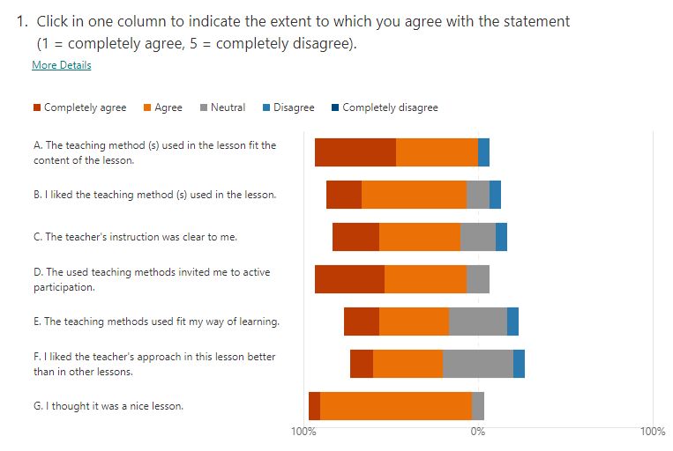

*Figure 1. Feedback from students*

I did not receive many long remarks/suggestions from my students, as can be seen in Figure 2 and 3. I will discuss the overall reflection on these remarks/suggestions on Section D.

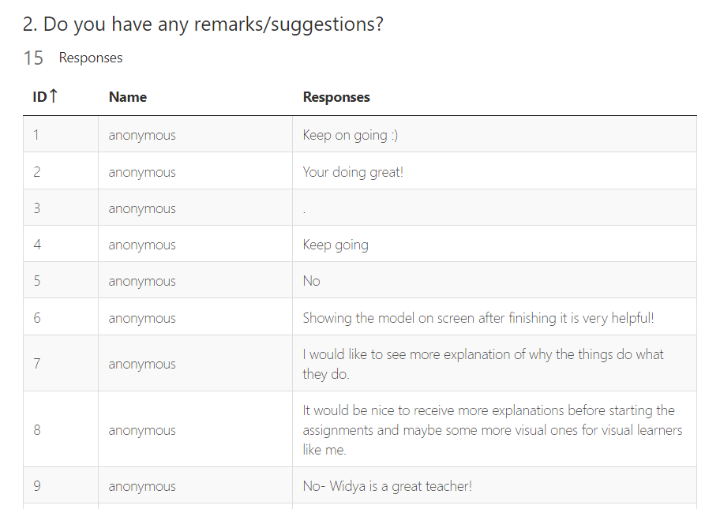

*Figure 2. Remarks/suggestions from students (part 1)*

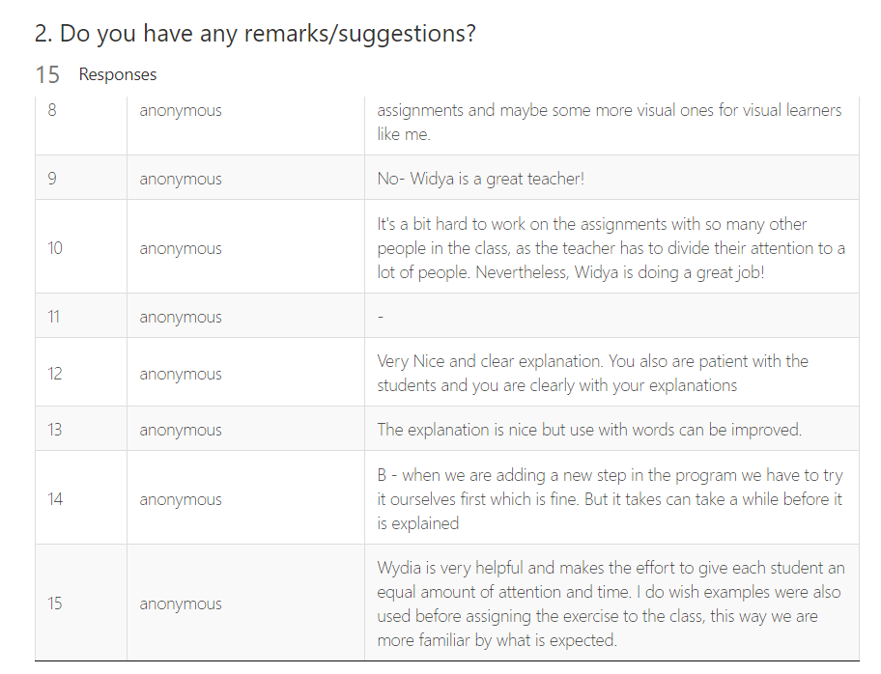

*Figure 3. Remarks/suggestions from students (part 2)*

1. **Reflection**

I am using Korthagen's reflection model to reflect on the feedback given by my students. Korthagen's reflection model is given in Figure 4. I am writing the five phases in different font colours to make them clear. Red, green, blue, purple, and orange correspond to action, looking back, awareness, alternative, and trial, respectively. Some reflection was already included shortly in Section C where I described the results of the feedback form, so in this section D I am going to elaborate more on my overall reflection, especially the ones shown on Figure 2 and 3.

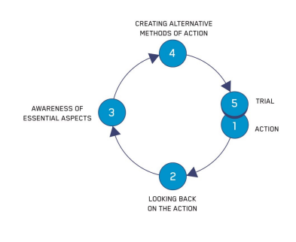

*Figure 4. Korthagen's ALACT reflection model*

Doing this as a hybrid lesson was a bit difficult, but I am happy with the feedback (they agreed that I was trying my best). I used many activation forms to make my lesson interactive, including questions-answers at the beginning of the lesson, peer-instruction/presentation, peer feedback, and discussions with peers. Based on the feedback given by students, I understand that students like the teaching methods that I use, however, not everybody likes modeling or can create model easily. I am aware that modeling is not an easy thing to do, it was not even easy for me. I am aware that creating a model is not something that fits everybody’s passion or interest. I think it will be nice to keep the balance between my instruction and students instruction. I can probably give better explanation because I have the didactics and pedagogic skills, however, when the students give presentation about their model, it can motivate their classmates and give them “wantivation” that they should be able to do that as well. Including a recording (uploaded on Brightspace) on how to build the model so students can watch back at home will be also a good option. I will explain more why the model should be like that, but keep trying to make it simple and easy to understand. The problem with modeling is that the math behind it is a bit too complicated for bachelor level as it is more for master level.

**References**

Fischer, E., & Hänze, M. (2019). Back from “guide on the side” to “sage on the stage”? Effects of teacher-guided and student-activating teaching methods on student learning in higher education. International Journal of Educational Research, 95, 26-35.

Hrmo, R., Krištofiaková, L., Vargová, M., Kučerka, D., Kmec, J., Rusnáková, S., & Biznárová, E. (2015, September). The research of the engineering pedagogy. In *2015 International Conference on Interactive Collaborative Learning (ICL)* (pp. 503-507). IEEE.

Molin, F., Haelermans, C., Cabus, S., & Groot, W. (2021). Do feedback strategies improve students’ learning gain?-Results of a randomized experiment using polling technology in physics classrooms. Computers & Education, 175, 104339.

Tureková, I., Hašková, A., Marková, I., & Bilčíková, J. (2020, November). Activating methods and their use in online education. In *Proceedings of ICERI2020 Conference* (Vol. 9, p. 10th).

Vilonen, K., Zitting, E., & Krause, O. (2008, July). Use of activating teaching methods in an introductory course of chemical processes. In SEFI annual conference in Aalborg.

Zhang, Z. V., & Hyland, K. (2022). Fostering student engagement with feedback: An integrated approach. Assessing Writing, 51, 100586.